**Catalog**

Part One Introduction 1

Visual interface: GUI 1

Part Two Input and Calculate 2

Step 1 : Inputted standard answer 2

Step 2 : Inputted student’s answer 3

Step 3 : Inputted weight 5

Step 4 : Inputted keyword 6

Step 5 : Inputted total score 7

Step 6 : Click the button"Calculate" 8

Part Three Results and Command button 9

Display results 9

Command button 9

# 

# Part One Introduction

**Visual interface: GUI**

In order to facilitate the use of users, we use the Tkinter Library of Python to build a graphical user interface called "GUI". "GUI" has the function of importing standard answers, students’ answers, weight, keywords and total score. In addition, it can calculate the score of students' answers and analyze the difficulty of each question through the inputted files, and save the results to the corresponding excel. The visual interface is shown in Figure 1.

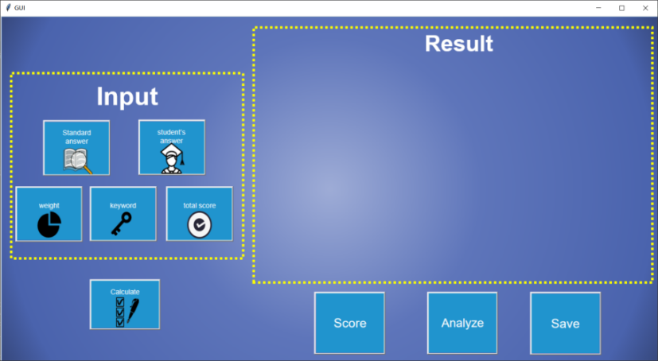

Figure 1: Visual interface"GUI"

The interface consists of several parts: (1) data import (left side) includes standard answers, student answers, weight, keywords and total score. (2) The calculate button (lower left corner) is used to score students' answers. (3) Result display (right side): when the program calculation is completed, a table will appear at this position to display the result. (4) The command buttons (bottom right corner) include "Score", "Analyze", "Save". The function of "Score" is to display the score of students' answers. The function of "Analyze" is to display the analysis of each problem. The function of "Save" is to save the results to an excel file. The result interface is shown in Figure 2.

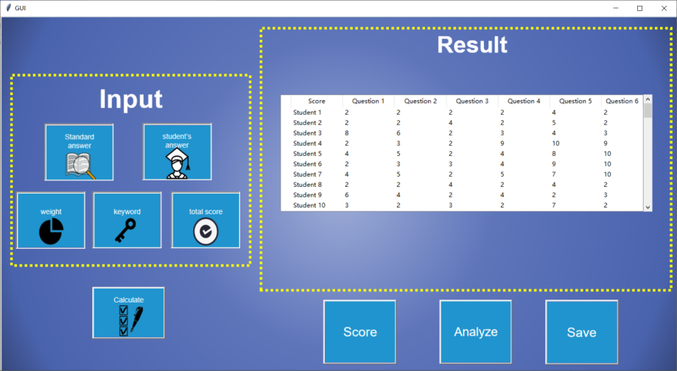

Figure 2: The result interface

# Part Two Input and Calculate

**Step 1 : Inputted standard answer**

Click the interface button "Standard answer" and input the corresponding file. It is worth noting that the suffix format of each inputting file "Standard answer" is ".xlsx", the first column is the label of each question, and the second column is the standard answer of each question. The process of inputting standard answers is shown in Figure 2 and figure 3. The file format is shown in Table 1.

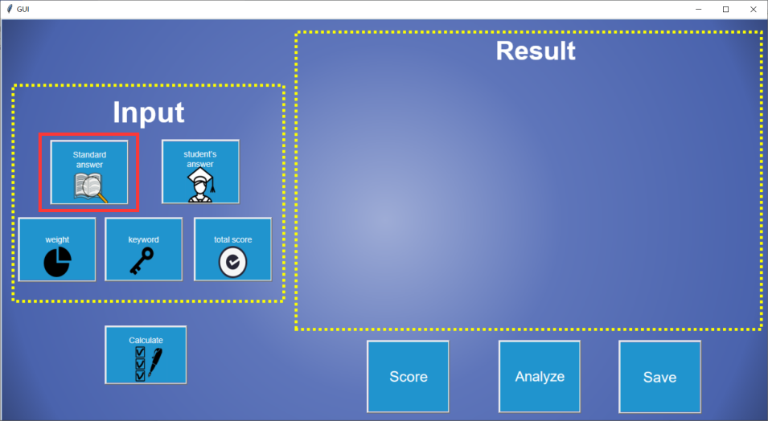

Figure 3: Click the interface button "Standard answer"

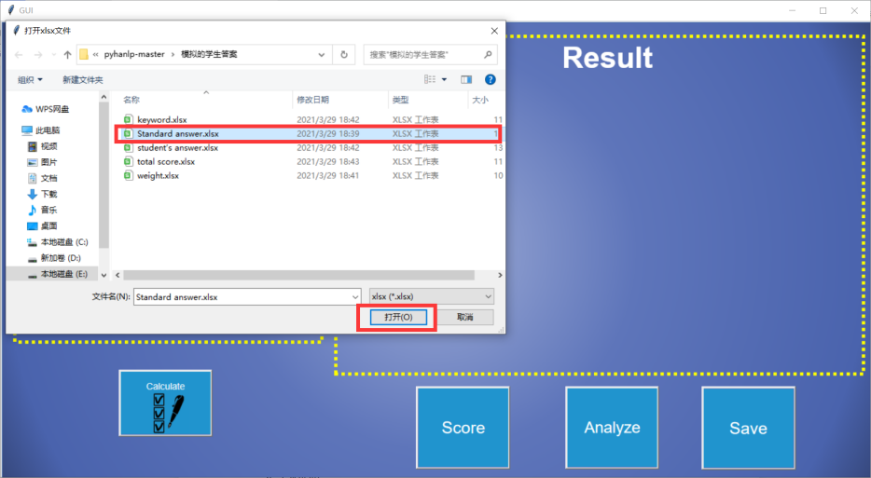

Figure 4: Input the file"Standard answer"

Table 1: File "Standard answer" format

|  |  |
| --- | --- |
| Question | Standard answer |
| 1 | 健康行为：是指有助于个体在生理、心理和社会上保持良好状态、预防疾病的行为。它与健康信念密切相关，是个体为维持、实现、重建健康和预防疾病的活动。 |
| 2 | 自我效能：是个体对自己成功执行某行为并导致预期结果的信念，属于自信范畴。自我效能在制定健康生活目标的意向阶段、具体行为改变阶段、防止复发过程中都具有重要的调节作用。自我效能来源于成功的经验、替代性经验、言语劝导和生理状态等四方面。 |
| 3 | 药物成瘾：是指强迫性、失去控制的用药行为，是药物的精神依赖性和生理依赖性共同造成的结果。能成瘾的药物具有引起精神愉悦或缓解烦恼的作用，这是触发条件。 |
| 4 | 酗酒：也称为酒精滥用或问题饮酒，它是造成躯体或精神损害或不良社会后果的过度饮酒。其特点是对饮酒不能自控，思想关注于酒，饮酒不顾后果；思维障碍；每一症状可以是持续或周期性的。 |
| 5 | 网络成瘾：是指慢性或周期性的对网络的着迷状态，不可抗拒的再度使用的渴望与冲动，上网后欣快，下网后出现戒断反应，出现生理或心理的依赖现象。 |
| 6 | 肥胖：是指体内过量脂肪堆积而使体重超过某一范围，当肥胖影响健康或正常生活及工作时才称为肥胖症。 |

**Step 2 : Inputted student’s answer**

Click the interface button "Student’s answer" and input the corresponding file. It is worth noting that the suffix format of each file "Student’s answer" is ".xlsx". The first column is the label of each question, and the beginning of the second column is the student's answer. The process of inputting student’s answer is shown in Figure 5 and figure 6. The file format is shown in Table 2.

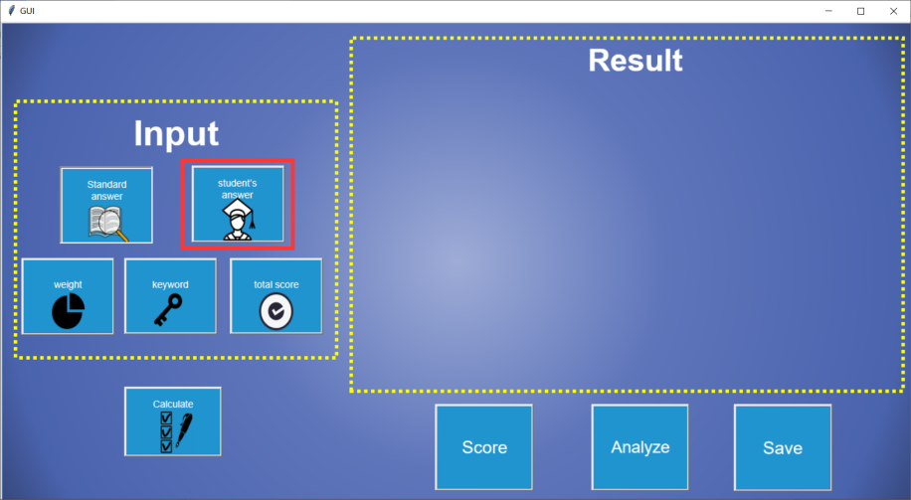

Figure 5: Click the interface button "Student’s answer"

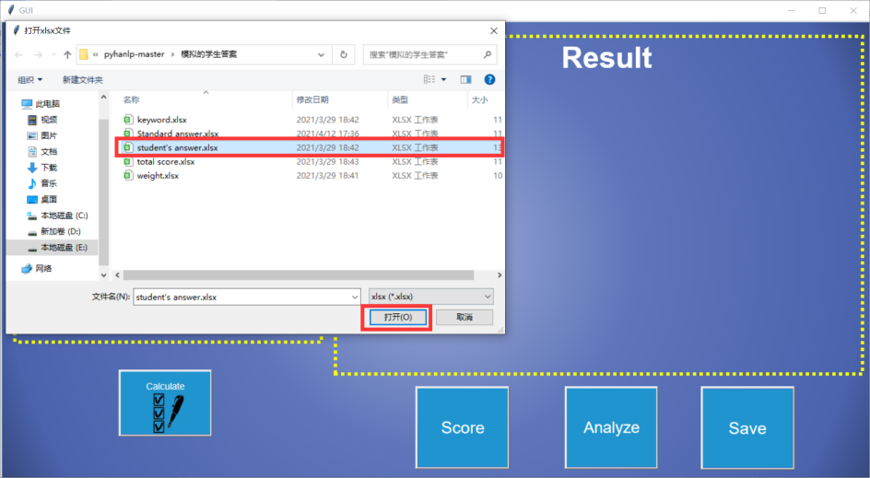

Figure 6: Input the file "Student’s answer"

Table 2: File "Student’s answer" format

|  |  |  |
| --- | --- | --- |
| Question | 1631250023 | 1632240016 |
| 1 | 健康行为：任何与疾病预防、增进健康、维护及恢复健康相关的行动。这类行为均可以是自愿的，也可能是不自愿的；可以直接从健康为目的的主动行为，也可以遵守法律或规定的被动行为。 | 健康行为：指任何与疾病预防、增进健康、维护健康及恢复健康相关的行动。这类行为可以是自愿的，也可能是不自愿的，可以是直接以健康为目的的主动行为，也可以是遵守法律或规定的被动行为。 |
| 2 | 自我效能：人对自己是否能够成功地进行某一成就的主观判断，它与自我能力感是同义的。这种理论认为，即便人的行为没有对自己产生强化，但由于人对行为结果所能带来的功效产生期望，可能会主动性的进行那一活动。 | 自我效能：是社会学习理论的创始人班杜拉从社会学习的观点出发，在1977年提出的，用以解释在特殊情景下动机产生的原因。 |
| 3 | 药物成瘾：是指药物与躯体相互作用而引起精神及躯体方面的改变患者为再度体验药物所致的兴奋感、舒适感，而周期地、持续地使用某种药物。 | 药物成瘾：指躯体和药物相互作用而引起的精神方面和躯体方面的改变，并在行为上常常有为了再度体验这些药物的精神效果，有时为了避免没有药物而产生的不快感而周期性地、持续地使用药物这一种强迫性愿望的特征。可存在或不一定存在耐药性，但同一个人可存在一种以上药物依赖性。 |
| 4 | 酗酒：指无节制地过量饮酒，能使人不同程度地丧失和降低自控能力，实施某种有伤风化或违法犯罪的行为，各国刑法和犯罪学家都认为酗酒行为有一定的社会危害性，但对危害的严重程度认识不同。 | 酗酒：是指无节制地过量饮酒，使人不同程度地降低甚至丧失自控能力，实施某种有伤风化和违法犯罪的行为。 |
| 5 | 网络成瘾：是上网者由于长时间地和习惯地沉浸在网络时空当中，对互联网产生强烈地依赖，以至于达到了痴迷的程度而难以自我解脱的行为状态和心理状态。 | 网络成瘾：是指上网者由于长时间地和习惯性地沉浸在网络的时空中，对互联网产生了强烈的依赖，以至于达到了痴迷的程度而难以自我解脱的行为状态和心理状态。 |
| 6 | 肥胖：一定程度的明显超重于脂肪层过厚，是体内脂肪，尤其是甘油三酯积聚过多而导致的状态，由于食物摄入过多造成体重过度增长并引起人体病理，生理改变或潜伏。 | 肥胖：指人体脂肪的过量储存，表现为脂肪细胞增多或细胞体积增大，即全身脂肪组织块增大，与其他组织失去正常比例的一种状态。 |

**Step 3 : Inputted weight**

Click the interface button "weight" and input the corresponding file. It is worth noting that the suffix format of each weight file is ".xlsx". The first column is the label of each question, the second column is the keyword similarity weight, and the third column is the semantic similarity weight. The process of inputting weight is shown in Figure 6 and figure 7. The file format is shown in Table 3.

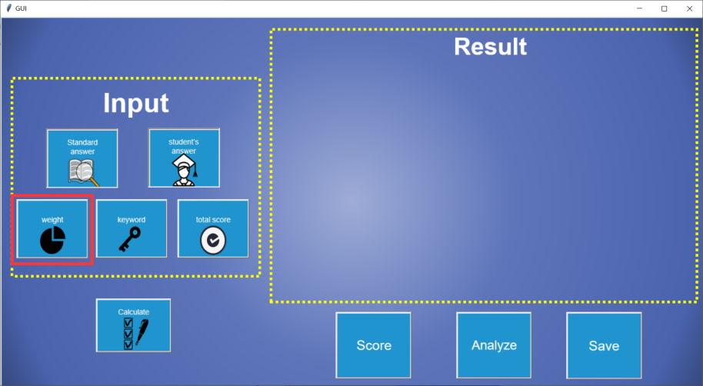

Figure 7: Click the interface button "weight"

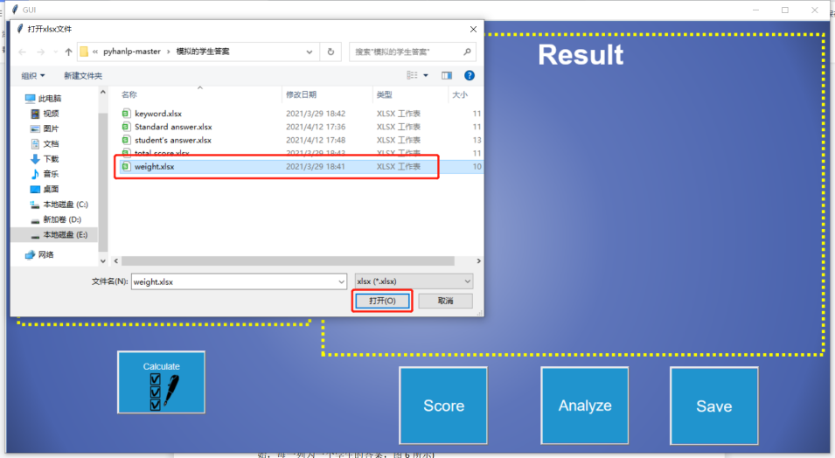

Figure 8: Input the file "weight"

Table 3: File "weight" format

|  |  |  |
| --- | --- | --- |
| Question | keyword similarity weight | semantic similarity weight |
| 1 | 0.5 | 0.5 |
| 2 | 0.5 | 0.5 |
| 3 | 0.5 | 0.5 |
| 4 | 0.5 | 0.5 |
| 5 | 0.5 | 0.5 |
| 6 | 0.5 | 0.5 |

**Step 4 : Inputted keyword**

Click the interface button "keyword" and input the corresponding file. It is worth noting that the suffix format of each keyword file is ".xlsx". In addition, the first column is the label of each question. At the beginning of the second column, each row is keywords of a question, and each keyword occupies one cell. The process of inputting keyword is shown in Figure 9 and figure 10. The file format is shown in Table 4.

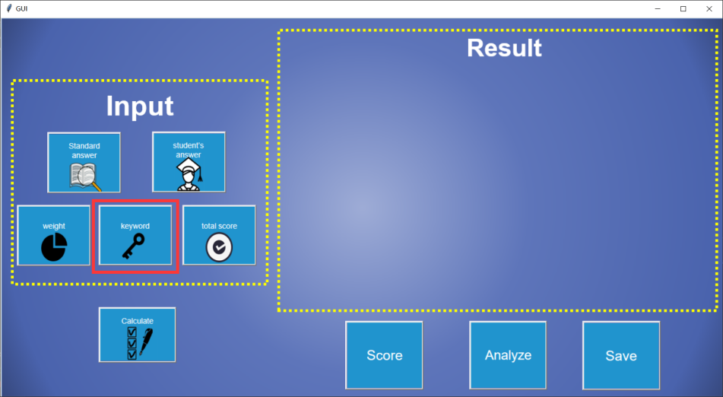

Figure 9: Click the interface button "keyword"

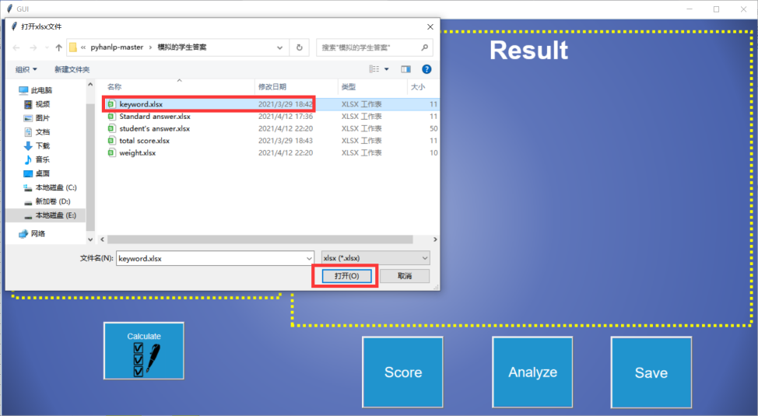

Figure 10: Input the file "keyword"

Table 4: File "keyword" format

|  |  |  |  |  |  |  |  |  |  |  |  |
| --- | --- | --- | --- | --- | --- | --- | --- | --- | --- | --- | --- |
| Question | keyword | | | | | | | | | | |
| 1 | 保持良好状态 | 预防疾病的行为 | 健康信念 | 维持 | 实现 | 重建健康 | 预防疾病 |  |  |  |  |
| 2 | 成功执行某行为 | 预期结果的信念 | 意向阶段 | 具体行为 | 改变阶段 | 防止复发过程 | 调节作用 | 成功的经验 | 替代性经验 | 言语劝导 | 生理状态 |
| 3 | 强迫性 | 失去控制 | 精神依赖性 | 生理依赖性 | 精神愉悦 | 缓解烦恼 |  |  |  |  |  |
| 4 | 过度饮酒 | 饮酒不能自控 | 思想关注于酒 | 饮酒不顾后果 | 思维障碍 |  |  |  |  |  |  |
| 5 | 慢性 | 周期性 | 网络的 | 着迷状态 | 不可抗拒 | 戒断反应 |  |  |  |  |  |
| 6 | 体重超过某一范围 | 肥胖症 |  |  |  |  |  |  |  |  |  |

**Step 5 : Inputted total score**

Click the interface button "total score" and input the corresponding file. It is worth noting that the suffix format of each total score file is ".xlsx". What's more, the first column is the label of each question, and the second column is the full score of each question. The process of inputting total score is shown in Figure 10 and figure 11. The file format is shown in Table 5.

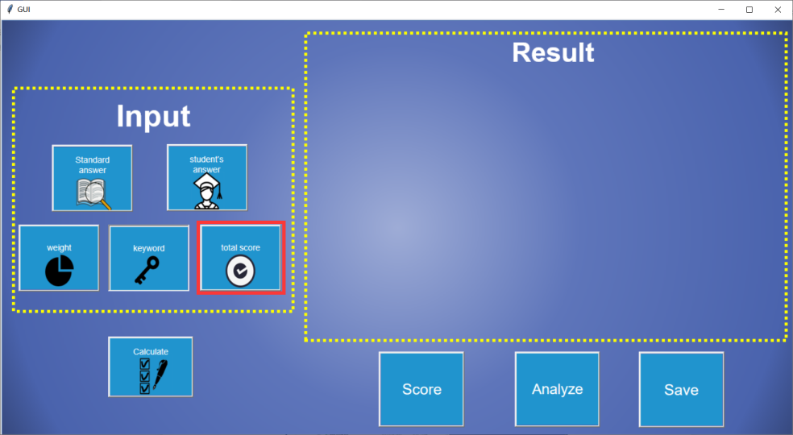

Figure 11: Click the interface button "total score"

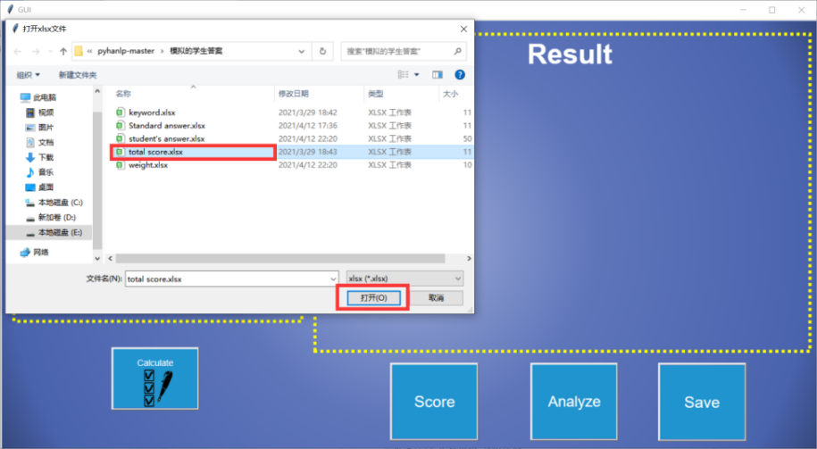

Figure 12: Input the file "total score"

Table 5: File "total score" format

|  |  |
| --- | --- |
| Question | total score |
| 1 | 10 |
| 2 | 10 |
| 3 | 10 |
| 4 | 10 |
| 5 | 10 |
| 6 | 10 |

**Step 6 : Click the button"Calculate"**

Click the interface button "Calculate", and then please wait patiently. The corresponding result will appear after the calculation., as shown in Figure 13.

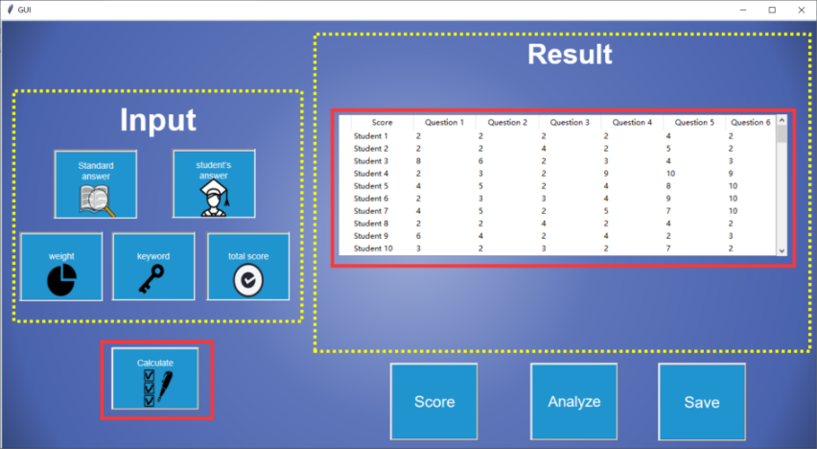

Figure 13: Click the interface button "Calculate"

# Part Three Results and Command button

**Display results**

When the scoring result is calculated, the score of students' answers will be displayed under "result", as shown in Figure 14.

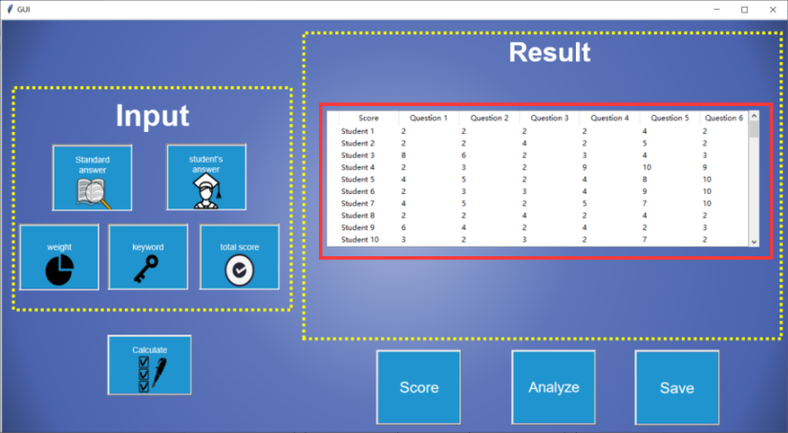

Figure 14: Display results

**Command button**

The button "Score" enables the display result to show the score of each student's answer, as shown in Figure 15. Due to the size of the interface, only 6 questions and each student's score can be displayed in the "GUI". However, the results saved by the "Save" button will display the complete results.

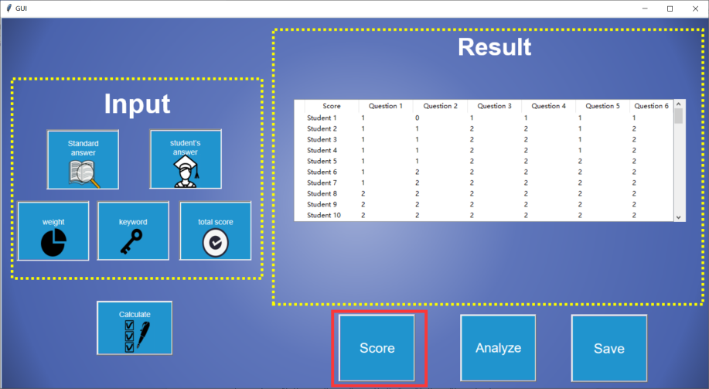

Figure 15: Function "Score"

The button "Analyze" enables the display results to display some analysis of each question. In the "GUI" interface, due to the size of the interface, only "the lowest score", "the highest score", "degree of diversity" and "coefficient of difference" can be displayed. The results are shown in Figure 16. However, the results saved by the "save" button will be analyzed more.

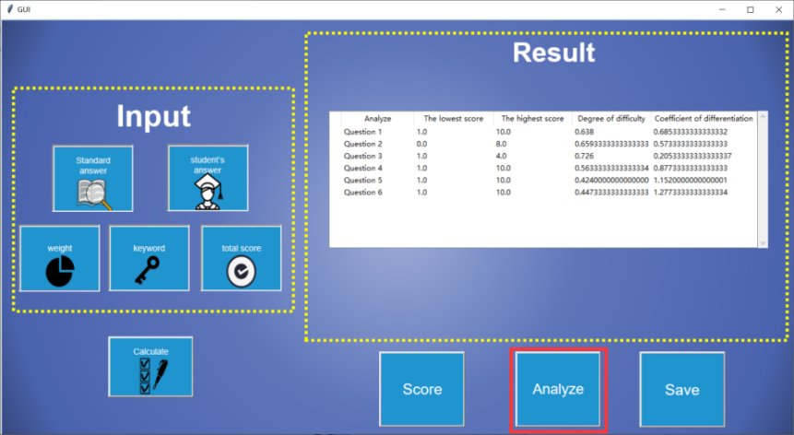

Figure 16: Function "Analyze"

The button "save" saves the results to an excel file. The document will be published in "GUI.exe" Under the same directory and named "Result.xlsx". The file has two tables called "score" and "analyze". Save the scores of the student answers and the analysis of each question, as shown in Figure 17.

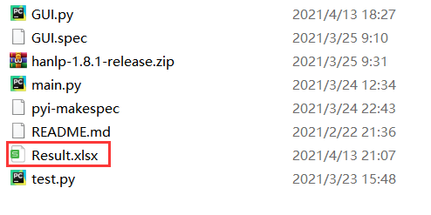

Figure 17: Result.xlsx